Walton-on-Trent CofE Primary and Nursery School
Spirituality Statement


Rationale:
As a Church of Egland school, we recognise and understand the importance of developing and promoting spiritual development in our young people:
’For a human being, especially a child or young person, to have a full quality of life, spirituality in all its aspects must be nurtured and affirmed’ (John Bradford).

‘The spiritual dimension has everything to do with who and what our pupils are and who and what they will become’ (Alison Farnell – The Stapleford Centre).

‘Spirituality embraces our central values; it is the source of all we so in life’ (Ian Dewar).

Our theologically-rooted Christian vision is:

To be a vibrant learning community aspiring to celebrate God's love and the uniqueness of each individual. This means offering kindness, honesty and respect to our local and global community and demonstrating courage, perseverance and ambition in order to flourish in the joy and hope of 'life in all its fullness' (John 10:10)

Introduction
In our school we believe in supporting the growth and development of the whole person for all those for whom we have a responsibility. This therefore includes staff (at all levels), children and, where appropriate/possible, their families. When we talk about the whole person, we are referring to the physical, mental, emotional and spiritual aspects of who they are. In this document we aim to set out how we will try and support the spiritual development of each individual in our care. We have deliberately avoided the term policy as we acknowledge that each person is different, especially when it comes to how we understand and relate to spirituality, this is therefore a statement to help guide us in our support of each other in this area.

What is our shared understanding of spirituality?
Our shared understanding of spirituality comes from the direct gathering of ideas from all of our stakeholders during March 2025. The below word web shows the variety of responses we received:
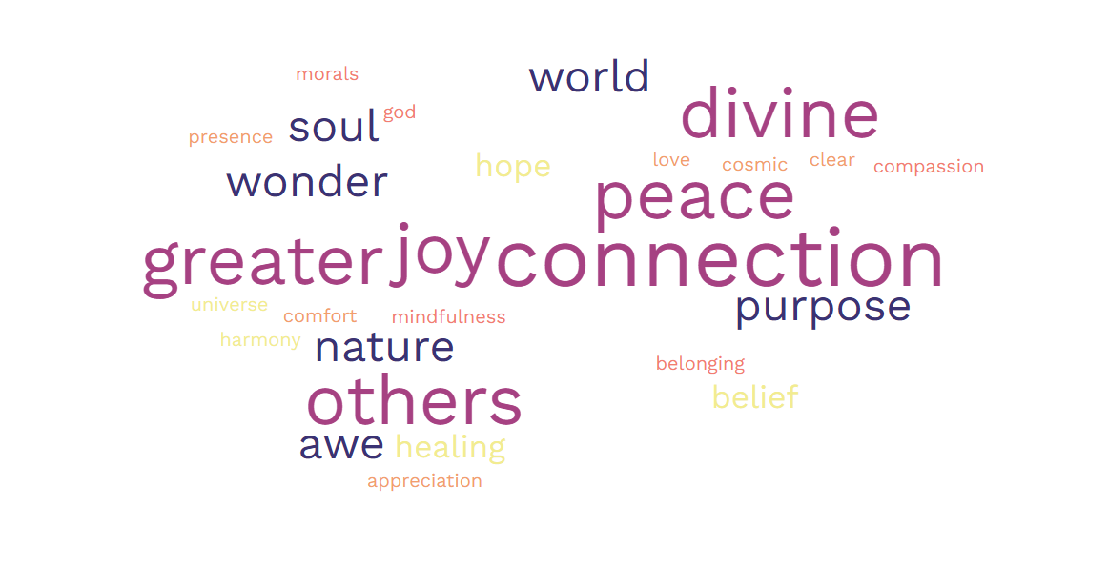
Spirituality in its widest sense speaks about something internal, the human spirit or soul as opposed to the external material or physical things.
For us as a C of E school it is more than that, it is about an awareness of ourselves as created by God in relationship with God, other people and the world around us. This does not mean we expect people to share our Christian faith or believe that this statement is not relevant to those of other faiths or none, but it is the foundation we build upon and therefore support others from.
Spirituality then is about recognising our place in this world and our connection with it, with one another and with God and exploring how that reflected in our daily lives.
From our collected ideas, we created a school motto for spirituality which the children have learned through actions. We have supported our SEND leaners by also dual-coding the words:

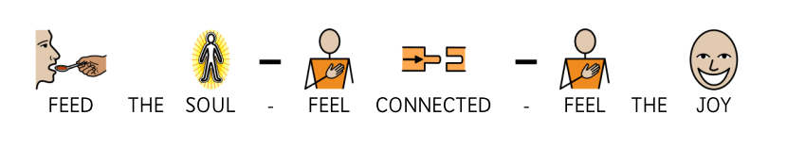

How do we support spirituality at our school?
As already expressed as a C of E school our spiritual foundation is built upon our Christian nature and ethos. We therefore seek that all we do is done in the light of that spiritual foundation. Specifically, we seek to raise spiritual awareness in the following ways:
• Through example – The way we model behaviour, conversation and care for one another should reflect love, compassion, respect and an awareness of the world around us. These are closely reflected in our school TAKE CARE rules which are reflected in a display in the school Hall and frequently referred to in our daily practice (including weekly ‘Take Care Champion’ awards given out in Shine assemblies on a Friday):
TAKE CARE OF OURSELVES
TAKE CARE OF EACH OTHER
TAKE CARE OF LEARNING
TAKE CARE OF OUR SCHOOL, OUR COMMUNITY & OUR WORLD
TAKE CARE OF OUR FUTURE
• Through teaching – Specifically in RE and PSHE but in all subjects where appropriate we will take opportunity to reflect on how our learning impacts our place in the world and how we should respond. More specifically within RE we will reflect on the teachings of various religions with a strong emphasis on Christianity (in line with the Statement of Entitlement) and what we learn about our relationships with the wider world.
• Through Collective Worship – We place a strong emphasis in Collective worship, whether it be whole school, class or in any other form. Our collective worship reflects our Christian foundation in all aspects and allows space for personal reflection upon how the Christian faith and teaching impacts and leads in our daily lives. It also offers space for prayer, either individual or led, and is inclusive and invitational to those of others faiths and those of none.
• Through our relationship with the church – As a school we have a good relationship with the local church, St. Laurence’s, as well as with our Priest in Charge (Rev. Derek Arnold, Foundation Governor) and also Rev. Bill Moore, a retired vicar who still supports school alongside Derek. Together we seek to encourage all to engage with what scripture has to say to us and about us in relation to God as creator of the world and creator of us within his image.
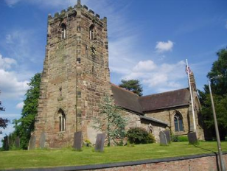
Building blocks
It is an impossible task within a document such as this to describe and explain all that Spirituality means to us and how we support and encourage its exploration and development as a school. This document therefore does not set out to do that but instead to establish some building blocks that when placed upon our Christian foundation, enable us to begin a journey of spirituality for each of us.

Some tools we use to develop a strong sense of spirituality
• Have regular time in the day for quiet and reflection
This is at the end of the day when we share a class book in all classes with the teacher reading aloud to the pupils. We will have training soon on Space Makers which we will use to further enhance our provision for quiet contemplation.
• Provide many opportunities for creativity and using the imagination
This is across all areas of the curriculum but may be most easily seen through creative writing and the creative and performance arts.
• Valuing play opportunities
The children at Walton get three opportunities to play throughout the school day, though this is more frequent in EYFS as the children are encourage to explore and learn about the world through a play-based curriculum. We are a small school but have a rich variety of activities available to support play, from a climbing frame and sand pit to bikes and bats and balls. We have a number of pupils with additional needs who are supported by adults to develop their play skills.
• Singing often, especially with others
Singing is an important part of our collective worship. We listen to a variety from across the world and through time through the ‘Musician of the Month’. We sing a variety of traditional hymns alongside more modern songs, all of which provide rich opportunities for discussion about meaning and what they teach us. We offer further enrichment through a school choir, open to all ages, who have performed in church services as well as at community events. In 2025, the Key Stage pupils got the opportunity to take part in Young Voices, where they sang alongside children from across the Midlands in front of an auditorium. We also have a Musical Theatre club, for pupils from Reception to Year 6, which has put on shows for the last three years.
• Ensuring regular time for prayer. This can take many forms, but should include being thankful, saying sorry. Allow children the opportunity to open themselves to God
Every collective worship, whether in class or as a whole school, contains an element of prayer. The children know and can recite our school prayer and the Lord’s prayer off by heart. Sometimes these prayers are used and sometime the leader will use a prayer more bespoke to the teaching of that session.
• Provide frequent opportunities for children to explore, express and share feelings
We are a ‘Speak Out: Stay Safe’ school (NSPCC), which means that we regularly talk to the children about the importance of sharing their feelings and having a trusted adult they can go to if they need to talk to someone. This is reinforced in a display in the entrance hall which identifies the Designated Safeguarding lead team and ChildLine posters. On this display, there is also reference to our ELSA team who can offer further bespoke to pupils who need a little more.
• Constantly reaffirm the importance of relationships. How we talk to and relate with each other is fundamental.
• Provide opportunities to express awe and wonder, appreciate beauty in all its forms, and appreciate the connections and unity in the world.
• Encourage each other to admit mistakes and to say sorry. Recognising and owning up to faults is an important healing and redemptive process.
This is supported by our restorative approach to behaviour management, where children are encouraged to reflect on the situation, their actions and their impact on others alongside what other choices they could have made.
• Encourage children to show kindness, caring and compassion, and to express these in practical ways. (eg: how we treat each other every day; charitable works; looking after pets).
This is strongly reflected in our school personal values of KINDNESS, HONESTY and RESPECT. These are reflected in how we all treat each other every day and are promoted widely. Our children are always looking for ways to support others and frequently hold fundraising events, such as bake sales, to raise money for causes that are important to them. We are also taking part in the World Environment Day soon where the whole school will engage in a project to promote sustainability within our school and the local community too.
• Explore the ‘Big Questions’ – particularly through our RE programme
• Read often to children, and give them opportunities to discuss and reflect. This includes both secular and religious texts, in particular the Bible.

Impact: how do we know this is being effective?
Spiritually developed children love and accept themselves and enjoy good relationships with each other. They take an interest and delight in the world around them; they are open to what lies beyond the material (this may manifest itself in faith/belief in God). They are able to express and understand feelings, they have a strong moral sense and a love of what is good. They are able to enjoy quiet and stillness, they possess an active imagination, and show joy in creativity and discovering new skills.
We cannot use a standardised test to judge this though it is tangible to visitors when they visit our school:

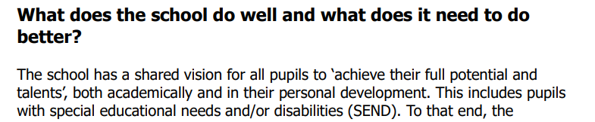
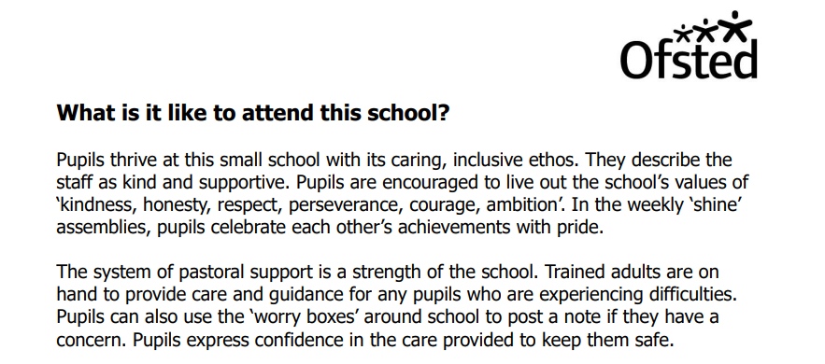

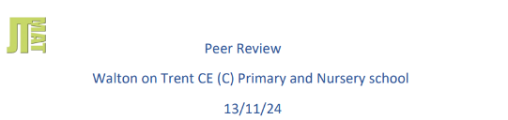

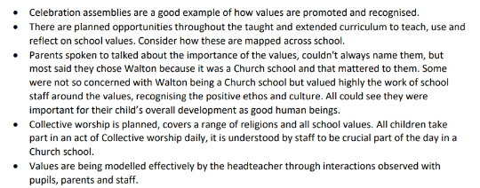
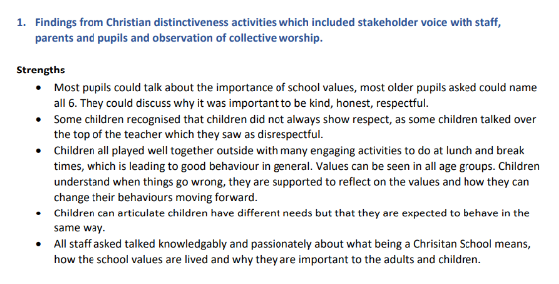

This statement was written, through collaboration with all stakeholders, in 2025. It should be revised annually in line with the Procedure for R.E. and Collective Worship.

